A CONDITIONAL EXCEEDANCE FRAMEWORK FOR INTERPRETABLE TRADING DECISIONS
Single-Asset Validation of the Conditional Probability of Exceedance Construct on SPY, with Strict Out-of-Sample Evaluation
Arun Ramanathan S
Singapore
arun.ramanathan.sg@gmail.com
Abstract
This paper makes two distinct contributions and keeps them clearly separated. First, a descriptive finding, verified independently of any trading outcome (Section 8.10): conditioning SPY’s forward price moves on comparable past moves systematically raises the probability of a future exceedance, with positive lift in all 54 tested horizon-threshold combinations (mean 2.56×). Second, a predictive test (Sections 7–8) of whether thresholding that probability into a mechanical entry rule, fully specified as numbered equations with every parameter frozen before 2025, produces a trading edge. It does not. The strategy underperforms SPY buy-and-hold on capital-weighted return in all three active configurations (Section 8.5), and its portfolio-level Sharpe (0.62–1.15, Section 8.4) is statistically indistinguishable from a randomly-timed exposure of the same size — confirmed by a within-strategy randomisation test and an independent random-entry benchmark using no parameters from the conditioning analysis (Section 8.8). We report both the per-trade-normalised statistics implied directly by the equations (Eq. 11, 13) and the capital-constrained, account-realisable analogues (Eq. 11c, 13d), since the two differ by 108–147× and must not be conflated (Section 8.3). A 23-year walk-forward extension (2003–2025, same train-on-prior-data discipline; Section 8.12) shows the gap widens, not narrows, with more history: 2.3 percent annualised against SPY’s 11.0 percent, because an entry rule requiring a prior sustained rise is structurally excluded from the sharp post-crash recoveries that drive much of the index’s long-run return. Underperforming buy-and-hold is not unusual — 79 percent of active large-cap managers did the same in 2025 (SPIVA; Section 8.7) — and this paper’s contribution is the verified descriptive structure and auditable methodology, not a demonstrated edge. The companion Conditional Exceedance Atlas (Ramanathan, 2026b; Section 3) extends the same construct descriptively across 161 instruments and two applied multi-predictor dashboards, whose performance under this same discipline remains an open question (Section 8.15).

1. Introduction
Much of quantitative trading research focuses on prediction: forecasting next-period returns, estimating expected returns, or learning price dynamics using increasingly complex statistical and machine learning models. While such approaches can be effective, they often obscure a simpler and more decision-relevant question: given that the market has already experienced a large move over a certain time horizon, how likely is another large move over the same horizon?
This work is motivated by that question. Rather than attempting to predict prices or returns directly, the analysis frames trading as a conditional probability problem — estimating the likelihood of future price exceedances given past exceedances. The objective is not to maximize in-sample fit or construct a high-frequency signal, but to develop a statistically interpretable framework that maps naturally to trading decisions under uncertainty. The emphasis throughout is on transparency, explicit uncertainty control, and a strict separation between the period over which parameters are estimated and the period over which the resulting strategy is evaluated.
The construction is deliberately minimal. A single asset (SPY), a single increment definition, and a small number of tunable thresholds are used to keep every step auditable: every trade traces back to an explicit conditional-probability statement computed from pre-2025 data alone. This minimalism is a design choice rather than a limitation of scope — it is what makes the strict out-of-sample test in Section 7 meaningful, and it is also what motivated the subsequent multi-asset extension described in Section 3, where the same logic is applied descriptively across a much larger instrument universe without an accompanying predictive claim.

2. Related Work
The construction here is a finite-sample, fixed-threshold relative of the tail-dependence coefficient used in extreme value theory, which is defined as a limiting conditional exceedance probability as the threshold approaches the support boundary (Coles, Heffernan and Tawn, 1999; McNeil, Frey and Embrechts, 2015). The present framework fixes the threshold at a finite, pre-estimated quantile rather than taking that limit, which sacrifices the asymptotic justification in exchange for a quantity that is directly interpretable as a sample relative frequency and that maps without further modelling onto a trading rule.
Conditional exceedance probabilities of a similar form appear in the systemic-risk literature, most notably in the CoVaR construction of Adrian and Brunnermeier (2016), where the object of interest is the value-at-risk of one institution conditional on another being in distress. The present application differs in two respects: it is single-asset and self-referential, conditioning an asset’s own future behaviour on its own past behaviour rather than on a second entity, and it is designed from the outset to generate a mechanical trading rule rather than a risk metric for a designated set of institutions.
Survival and hazard-style modelling offers a useful conceptual frame for the threshold-crossing logic used here, in which an exceedance plays the role of an event and the conditional probability table plays the role of a hazard function indexed by horizon and threshold rather than by elapsed time (Wuthrich and Merz, 2023). The framework also sits adjacent to the regime-detection literature — Pagan and Sossounov (2003) on bull and bear market identification, and Ang and Bekaert (2002) on international regime shifts — in that both approaches partition a price history into discrete states and condition forward behaviour on the current state; the difference is that exceedance events here are defined purely by quantile crossings of a fixed-horizon increment rather than by a fitted regime-switching model.
This single-asset study is closely related to, and is the methodological predecessor of, the multi-asset Conditional Exceedance Atlas (Ramanathan, 2026b), which computes the same conditional-probability construct across a 161-instrument universe spanning equities, cryptocurrencies, commodities, fixed income, volatility and foreign exchange. The two studies differ in aim in a way that matters for how each should be read, and that distinction is taken up explicitly in Section 3.

3. Relation to the Multi-Asset Atlas and Scope of the Predictive Claim
Because this paper and the companion Atlas use the same underlying statistic — a conditional probability of exceedance estimated from quantile-threshold crossings — it is important to be precise about how their claims differ, since conflating them would overstate what either result supports on its own.
The Atlas is explicitly descriptive. Every threshold used in that study is an in-sample, full-history empirical quantile, no holdout period is reserved, and no forecasting claim is made or implied; the stated aim is to characterise the historical geometry of joint tail co-movement across a large cross-asset universe, not to certify a tradeable signal. The present paper is narrower in scope but stronger in claim: a single asset, a single increment definition, and a small, pre-registered grid of thresholds, with every probability table frozen using data through the end of 2024 and every reported performance figure computed exclusively on 2025 data that played no role in threshold selection. The predictive claim made here is therefore limited strictly to this single-asset, single-period construction, and should not be read as validating the cross-sectional structure documented in the Atlas, which carries no out-of-sample test of its own.
The relationship runs in one direction only: the Atlas’s Section 9 signal-score illustration cites this paper’s out-of-sample Sharpe ratios as evidence that the underlying conditional-exceedance logic can in principle be operationalised into a trading rule, while explicitly declining to extend that out-of-sample validation to the multi-asset setting. This paper does not draw on the Atlas’s cross-sectional findings to support its own single-asset result; the two are designed to be read independently, and the out-of-sample evidence presented in Sections 6–7 below stands on its own.

4. Data and Experimental Design
The analysis uses daily adjusted close prices of SPY, a highly liquid, broad-market U.S. equity ETF chosen for its long history, minimal corporate-action noise relative to single names, and absence of the short-history caveats that complicate several instruments in the companion Atlas.
- Instrument: SPY (SPDR S&P 500 ETF Trust), daily adjusted close
- Training period: inception through December 31, 2024
- Evaluation period: January–December 2025 (strictly out-of-sample)
- Frequency: daily, overlapping τ-day windows stepped one trading day at a time
- Transaction costs and slippage: not included in the reported figures; their omission is discussed as a limitation in Section 9
All probability estimates, quantile thresholds, and statistical filters are computed exclusively using data dated on or before December 31, 2024, and are frozen prior to the start of the evaluation window. No parameter — including the horizon τ, the conditioning and target quantile levels q and r, or the reliability filters described in Section 6 — is re-estimated, adjusted, or selected using 2025 data at any point. This separation is the single most important methodological feature of the study: the out-of-sample results in Section 7 are a genuine forward test against data unseen by the parameter-estimation step, not an in-sample fit re-described as a backtest.
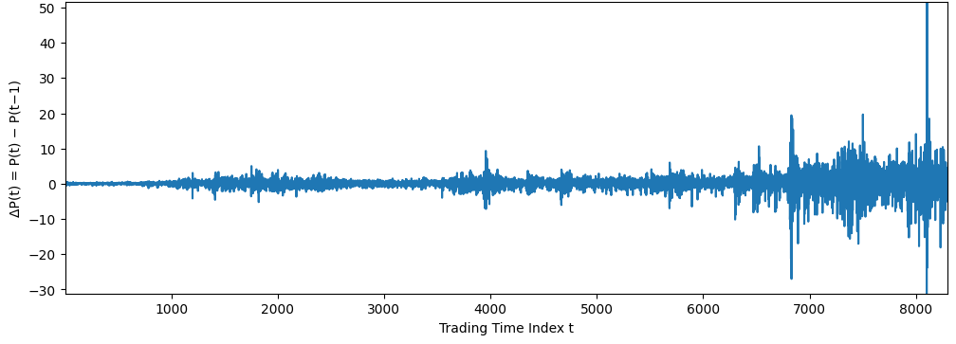
Figure 1. Daily price increment ΔP(t) = P(t) − P(t−1) for SPY across the full sample. Volatility clustering is visible, with markedly larger swings concentrated from roughly index 6500 onward, corresponding to the 2020 and subsequent stress episodes.
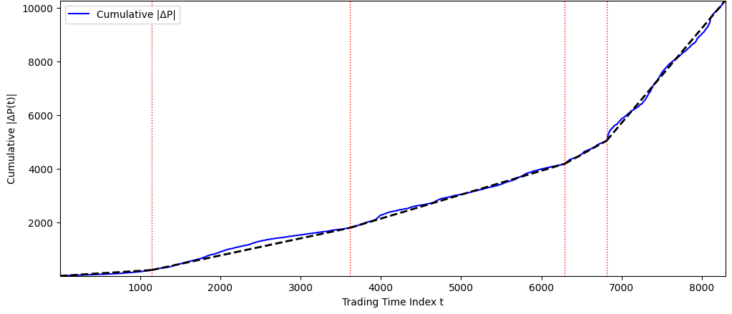
Figure 2. Cumulative sum of absolute daily increments, with a fitted linear trend (dashed) and four change-point markers (dotted red) identifying segments of differing average absolute movement. The series accelerates noticeably after each marked breakpoint, consistent with the regime heterogeneity that motivates the use of full-sample rather than rolling thresholds being treated with caution (see Section 9).

5. Methodology: The Conditional Exceedance Framework
For a fixed time horizon τ (in trading days), let P(t) denote the SPY adjusted close price at trading-day index t. The τ-day price increment is defined as
ΔP(t; τ) = P(t) − P(t − τ) (1)
Two exceedance events are defined relative to empirical quantile thresholds of this increment, estimated exclusively from training-period data Tₜᵣₐᵢₙ = { t : date(t) ≤ 2024-12-31 }:
q_thresh(τ, q) = Quantile_q ( { ΔP(t; τ) : t ∈ Tₜᵣₐᵢₙ } ) (2)
r_thresh(τ, r) = Quantile_r ( { ΔP(t; τ) : t ∈ Tₜᵣₐᵢₙ } ) (3)
A past exceedance at time t occurs when ΔP(t; τ) ≥ q_thresh(τ, q); a future exceedance occurs when ΔP(t + τ; τ) ≥ r_thresh(τ, r). The central object of estimation is the conditional probability of a future exceedance given a past exceedance, computed entirely on training-period data:
p̂(τ, q, r) = Pr [ ΔP(t + τ; τ) ≥ r_thresh(τ, r) | ΔP(t; τ) ≥ q_thresh(τ, q) ], t ∈ Tₜᵣₐᵢₙ (4)
with empirical estimator
p̂(τ, q, r) = N_qr / N_q, N_q = Σₜ ∈ Tₜᵣₐᵢₙ 1[ΔP(t;τ) ≥ q_thresh], N_qr = Σₜ ∈ Tₜᵣₐᵢₙ 1[ΔP(t;τ) ≥ q_thresh] · 1[ΔP(t+τ;τ) ≥ r_thresh] (5)
where 1[·] is the indicator function. Sweeping τ, q and r produces a multi-dimensional lookup table of conditional exceedance probabilities, with three properties motivating its use over a conventional forecasting approach: it requires no point forecast of price or return level, since N_q and N_qr are simple event counts; it focuses directly on tail behaviour, the regime in which most trading risk and opportunity is concentrated; and it maps without further modelling onto a trading decision, since p̂(τ,q,r) is by construction a probability that a mechanical rule can threshold against.
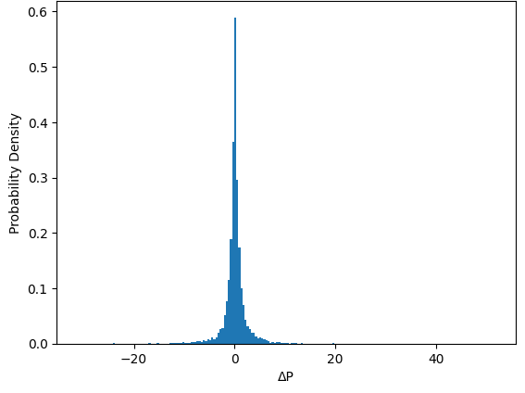
Figure 3. Empirical density of the daily price increment ΔP, pooled across the full sample. The distribution is sharply peaked and heavy-tailed relative to a Gaussian reference, which is the empirical basis for defining exceedance thresholds via quantiles rather than via a fixed multiple of a parametric standard deviation.

6. Statistical Reliability and Uncertainty Control
Conditional probabilities estimated from finite samples can be noisy, particularly in the tails, where the conditioning event itself is rare. For each parameter combination (τ, q, r), the reciprocal of the conditioning count N_q is used as a simple, conservative uncertainty metric:
u(τ, q) = 1 / N_q (6)
This is not a model-based Bernoulli standard error in the classical sense, since the underlying observations are constructed from overlapping τ-day windows and are not independent draws; it is better read as a simple, monotone penalty on configurations with few training-period conditioning episodes, consistent across every stage of the framework — the same convention is applied unchanged to the eligibility filter below and to the Sharpe ratio variance estimate in Section 7.2. This convention, and the interpretive limits it imposes, is discussed explicitly in Section 9.2.
A configuration (τ, q, r) is eligible to generate trades only if both of the following hold, evaluated entirely on training-period quantities:
p̂(τ,q,r) ≥ p_min and u(τ,q) ≤ u_max (7)
with p_min = 0.5 and u_max = 0.01 (equivalently, N_q ≥ 100) for every configuration reported in Table 1. A configuration failing either condition generates zero trades over the evaluation window by construction, regardless of how large its point estimate p̂ is — this is the direct and intended mechanism behind the zero-trade rows in Table 1, not a malfunction of the strategy.

7. Trading Strategy Design and Performance Computation

7.1 Entry, holding, and exit rule
The trading rule is mechanical and is applied independently for each eligible configuration (τ, q, r). Let Tₜₑₛₜ = { t : date(t) ∈ [2025-01-01, 2025-12-31] } denote the evaluation window. For each t ∈ Tₜₑₛₜ, a trade fires if and only if
fire(t) = 1 [ ΔP(t; τ) ≥ q_thresh(τ, q) ], q_thresh(τ, q) estimated on Tₜᵣₐᵢₙ only (Eq. 2) (8)
A fired trade opens a long position at price P(t) and exits mechanically at P(t + τ), with no stop-loss, take-profit, or intermediate adjustment. The set of trades generated for a given configuration is S(τ,q,r) = { t ∈ Tₜₑₛₜ : fire(t) = 1 }, and trades are allowed to overlap in calendar time — multiple positions opened on different entry dates within the same τ-day window may be held simultaneously. This is a deliberate design feature, not an oversight: every trade is sized and capitalised separately (Section 8.3 specifies the exact capital convention), and the framework intentionally does not deduplicate or down-weight temporally clustered signals, for the same reason the conditional probability table itself does not deduplicate clustered conditioning events (Section 6). This separate-capitalisation convention should not be read as a claim that overlapping trades are statistically independent — they are not, and Section 7.3 quantifies the resulting correlation explicitly.

7.2 Per-trade return
For a trade opened at t ∈ S(τ,q,r) and closed at t+τ, the realised profit and the simple per-trade return, normalised by that trade's own entry price, are
pnl(t) = P(t+τ) − P(t) (9)
ret(t) = pnl(t) / P(t) = P(t+τ)/P(t) − 1 (10)
Each trade's return is computed against its own entry price, not a fixed reference price; this point is made explicit here because an earlier version of the implementation incorrectly normalised every trade in a configuration by the price on a single fixed date, which is corrected in the released code (Section 12).

7.3 Aggregate return and Sharpe ratio
Let n = |S(τ,q,r)| denote the number of trades generated. The aggregate return reported in Table 1 is the simple sum of per-trade returns, consistent with a convention of one unit of capital allocated independently to every trade with no shared or constrained capital pool and no compounding across trades:
TotalReturn(τ,q,r) = 100 × Σₜ ∈ S ret(t) (11)
The Sharpe ratio is computed from the sample mean and sample standard deviation of the n per-trade returns,
ret̄ = (1/n) Σₜ ∈ S ret(t), s_ret = sqrt[ (1/(n−1)) Σₜ ∈ S (ret(t) − ret̄)² ] (12)
Sharpe(τ,q,r) = (ret̄ / s_ret) × sqrt(252 / τ) (13)
Equation 13 follows the standard convention of annualising a sub-annual return statistic by the square root of the number of periods per year, here taken as 252/τ — the number of non-overlapping τ-day blocks in a 252-trading-day year. Because trades are permitted to overlap (Section 7.1), n typically exceeds 252/τ substantially, and the n trade returns entering Equation 12 are not statistically independent: two trades opened on adjacent calendar days share τ−1 of their τ trading days and are therefore highly correlated. The Sharpe ratio in Equation 13 should accordingly be read as a per-trade, annualised risk-adjusted return statistic computed on the realised sample of (possibly clustered) trade outcomes, not as a claim that the underlying observations are statistically independent in the classical sense required for the usual sampling-theory interpretation of a Sharpe ratio. This is the same modelling convention used throughout the framework — identically in N_q (Eq. 5), u (Eq. 6), and Sharpe (Eq. 13) — and is discussed as an explicit interpretive limit in Section 9.2 rather than treated as a defect specific to the Sharpe computation.
Key characteristics of the strategy, all deliberate design choices rather than oversights, are summarised below:
- No signal aggregation across configurations — each (τ, q, r) triple is evaluated and reported independently
- No stop-loss or take-profit rule; the holding period is fixed by τ and never shortened or extended in response to price action
- Overlapping trades are allowed by design (Section 7.1); the same clustered-sample convention used for N_q and u is applied to the Sharpe ratio variance estimate
- No parameter tuning of any kind is performed on 2025 data; every threshold, filter bound, and horizon in Eqs. 2–7 is fixed before the evaluation window begins
Each trade therefore corresponds to a single, explicit, falsifiable probabilistic hypothesis formed entirely from pre-2025 information, evaluated according to Equations 8–13 above.
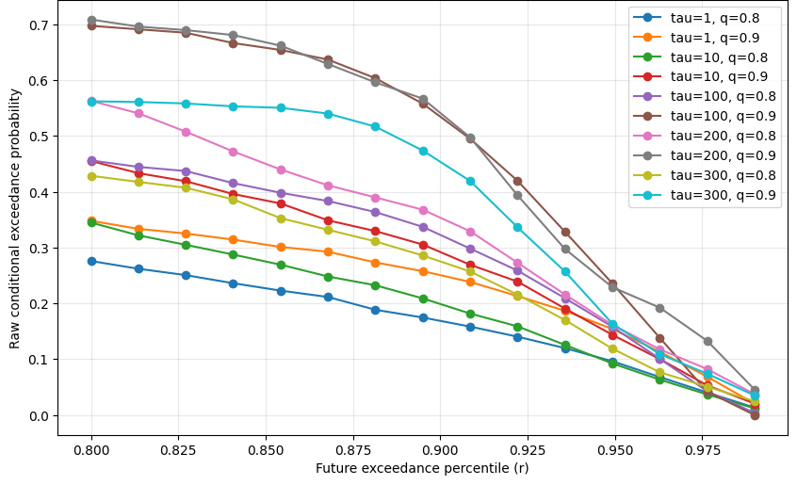
Figure 4. Raw (unfiltered) conditional exceedance probability as a function of the future exceedance percentile r, for nine combinations of horizon τ and conditioning threshold q, estimated on pre-2025 data. Longer horizons (τ = 100–300) sit systematically above shorter horizons (τ = 1, 10) across the threshold range, motivating the horizon ranges examined in the out-of-sample results of Section 8.

8. Out-of-Sample Results

8.1 Entry window versus realisation window
Before reporting performance figures, one definitional point must be stated precisely, because it affects how “out-of-sample” should be read in this paper. The evaluation window Tₜₑₛₜ (Eq. 8) restricts trade entry dates to calendar year 2025: a trade can only be opened if its entry date t satisfies date(t) ∈ [2025-01-01, 2025-12-31]. It does not restrict the exit date t+τ. For τ = 100–200 trading days, a position entered in the second half of 2025 exits roughly 4–5 calendar months later, which falls in early-to-mid 2026. Across the three active configurations in Table 1, this is not a marginal effect: 57–63 percent of trades in every active configuration have an exit date in 2026 rather than 2025.
This has two distinct consequences that should not be conflated. First, the entry-signal threshold q_thresh (Eq. 2) and the conditional probability table p̂ (Eq. 4–5) are trained exclusively on data through 2024-12-31 and are never re-estimated using 2025 or 2026 data; the entry decision itself is therefore genuinely out-of-sample with respect to the training period, exactly as Section 4 and the sanity check in the released code (Section 12) establish. Second, however, the realised return of a majority of individual trades (Eq. 9–10) depends on price data extending into 2026, which means the aggregate return and Sharpe ratio reported in Table 1 are not fully determined by calendar-year-2025 price action alone. A reader should therefore understand “out-of-sample” in this paper as applying to the entry rule and the training/evaluation split, not as a guarantee that every reported trade's outcome was realised within calendar 2025.
This is a data-window definition issue, not a data-integrity issue: the entry-signal threshold never sees post-2024 data at any point (Section 5–6), and exit prices are drawn from the same single, consistently-sourced price series used throughout, with no indication of staleness or artefacts in the post-2025 portion of that series. The issue is solely that the strategy's stated holding period extends the realisation horizon for late-2025 entries into 2026, and the headline figures below should be read with that in mind.

8.2 Headline results
Performance is evaluated on trades entered within Tₜₑₛₜ (2025) and realised through their full τ-day holding period regardless of calendar year (Section 8.1), using thresholds q_thresh, r_thresh and the probability table p̂ frozen on Tₜᵣₐᵢₙ (≤ 2024-12-31) per Equations 2–5, with Equations 8–13 applied unchanged to produce Table 1. Across the configurations reported, the strategy generates a cross-sectional Sharpe ratio (Eq. 13) in the approximate range 1.7–4.7 where trades fire at all, and aggregate returns (Eq. 11) in the approximate range 620–1860 percent on the configurations that traded. As established in Section 8.3 and Table 1a, this aggregate-return figure sums per-trade returns each normalised by its own entry price and does not represent a capital-constrained portfolio return; the capital-weighted return on the peak dollar capital actually required to hold every concurrent position is materially smaller, in the range 6–16 percent, and that figure — not Equation 11 — is the closer analogue to what a single funded trading account would have realised. Equation 13’s Sharpe ratio is similarly not directly comparable to standard portfolio-level usage of the term; Section 8.4 and Table 1b construct a portfolio-level Sharpe from the strategy’s actual daily mark-to-market equity curve, giving a materially lower range of 0.62–1.15, modestly above SPY’s own 0.95 buy-and-hold Sharpe over the identical window for the two τ=200 configurations and below it for the τ=100 configuration; Section 8.5 shows this Sharpe edge comes from lower volatility, not higher return — the strategy underperforms SPY buy-and-hold on raw, capital-weighted return in every active configuration. Three of the six examined configurations produced zero trades because no training-period conditioning sample satisfied the reliability filter of Equation 7; these are reported alongside the active configurations rather than omitted, since the zero-trade outcome is itself part of the honest record of what the pre-registered rule produced.
The most robust performance, in the sense of generating both a usable number of trades and a high realised Sharpe ratio, occurs at horizons τ = 100–200 trading days, where the training-period point estimate p̂ clears p_min = 0.5 (Section 8.1, Table 1). At τ = 300 the training-period conditional probability itself falls below 0.5 for both conditioning levels examined (p̂ = 0.36 in each case), despite ample conditioning support (491–1258 observations); the eligibility gate of Equation 7 is therefore rejecting these configurations on the probability criterion, not the sample-size criterion, indicating that the historical conditional structure at this horizon did not favour the directional bet during the training period, independent of how reliably that unfavourable estimate could be measured.
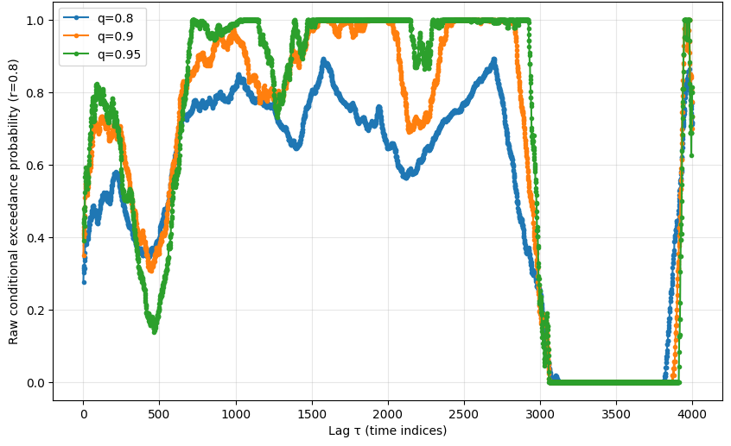
Figure 5. Raw conditional exceedance probability at fixed target threshold r = 0.80, plotted against lag τ in time indices, for three conditioning thresholds q ∈ {0.80, 0.90, 0.95}. The probability surface is regime-dependent rather than monotone in τ, with extended plateaus near zero (roughly indices 3000–3900) interrupting otherwise elevated conditional structure — a pattern consistent with the regime heterogeneity flagged in Figure 2.

Table 1. Out-of-sample performance for selected parameter configurations — entries in 2025, realised through full τ-day holding period (Section 8.1).
q | r | τ | p_min | u_max | Trades (n) | Exit in 2026 (%) | Eq.11 % (sum, not portfolio return) | CapWeighted % (Eq. 11c) | Sharpe (Eq. 13, cross-sect.)
0.8 | 0.8 | 200 | 0.5 | 0.01 | 117 | 57.3 | 1857.78 | 15.79 | 4.19
0.9 | 0.8 | 200 | 0.5 | 0.01 | 108 | 57.4 | 1646.49 | 15.20 | 4.68
0.9 | 0.8 | 100 | 0.5 | 0.01 | 147 | 63.3 | 622.54 | 6.03 | 1.70
0.8 | 0.8 | 100 | 0.5 | 0.01 | 0 | — | 0.00 | 0.00 | —
0.8 | 0.8 | 300 | 0.5 | 0.01 | 0 | — | 0.00 | 0.00 | —
0.9 | 0.8 | 300 | 0.5 | 0.01 | 0 | — | 0.00 | 0.00 | —
Note: q and r are literal quantile levels per Equations 2–3, not index labels. “Exit in 2026 (%)” is the share of trades in that configuration whose exit date falls in calendar 2026 rather than 2025, per Section 8.1; this share is large (57–63%) because τ = 100–200 trading days corresponds to roughly 4–5 calendar months, pushing late-2025 entries past the 2025/2026 boundary. “Eq.11 %” sums per-trade returns each normalised by its own entry price (Eq. 11) and is NOT a capital-constrained portfolio return; “CapWeighted %” (Eq. 11c) divides total realised dollar profit by the peak capital actually required to hold every concurrent position and is the figure most analogous to what a real, fully-funded account would have earned — it is 108–147× smaller than Eq.11 % across the three active configurations, and Section 8.3 / Table 1a give the full derivation including the dollar peak-capital figures. These figures supersede an earlier version of this table that was affected by two implementation issues, both since corrected and reconciled against a full per-trade ledger in the released code (Section 12): (i) the entry-signal threshold q_thresh was inadvertently computed on the full price series rather than on Tₜᵣₐᵢₙ only, and (ii) each trade's return was normalised by a single fixed reference price rather than by Equation 10. Configurations with τ = 100 (q=0.8) and τ = 300 (both q) register zero trades because the training-period point estimate p̂ fell below p_min = 0.5 (p̂ = 0.456, 0.363, and 0.361 respectively for the three zero-trade rows) — the underlying conditioning samples were in fact large (491–1488 observations, well above the u_max-implied floor of 100) and the se ≤ u_max bound was not binding in any of the three cases. The eligibility gate was therefore rejecting these configurations because the historical conditional probability itself was unfavourable, not because of insufficient data; an earlier version of this caption stated the reverse and has been corrected following independent verification against the underlying probability table. “Sharpe (Eq. 13)” is computed cross-sectionally across trade returns and is subject to the clustered-sample interpretation discussed in Section 7.3 and Section 9.2; Section 8.4 / Table 1b report a portfolio-level Sharpe computed from a real daily mark-to-market equity curve instead, which is materially lower (0.62–1.15) and is the figure most analogous to standard quantitative-finance usage of the term.

8.3 Capital convention: what Equation 11 does and does not measure
Equation 11 sums n per-trade simple returns, each individually normalised by that trade's own entry price (Eq. 10). The arithmetic is implemented exactly as defined, but the resulting quantity is not a meaningful return on any actual capital base — summing percentages that are each computed against a different denominator does not correspond to the return on $1, on the total capital deployed, or on any other fixed sum, for reasons made explicit in Section 8.3.1. Because trades overlap (Section 7.1), multiple positions are open simultaneously; the maximum number of trades concurrently open at any point within the evaluation window, and the corresponding peak dollar capital required to hold all of them at once (summing each open position's own entry price), are reported in Table 1a below for the three active configurations.
PeakCapital(τ,q,r) = maxₜ Σ { P(t′) : t′ ∈ S(τ,q,r), t′ ≤ t < t′+τ } (11b)
where the maximum is taken over every date t in the evaluation window and the inner sum runs over every trade whose holding period covers t. A capital-weighted return, computed as realised dollar profit and loss divided by this peak capital requirement, is a closer analogue to the return an actual fully-funded trading account would have realised:
CapWeightedReturn(τ,q,r) = 100 × [ Σₜ ∈ S pnl(t) ] / PeakCapital(τ,q,r) (11c)
Table 1a reports both quantities side by side, together with the dollar peak-capital figure that the percentage figures are built from; the capital-weighted percentage itself is also carried directly into Table 1 so that the two readings are never separated by more than a column. The gap between Equation 11 and Equation 11c is large — a factor of roughly 108–147× across the three active configurations — and is not a rounding or labelling issue: it is the direct arithmetic consequence of summing n separately-normalised percentage returns (Eq. 11) instead of dividing total dollar profit by the capital actually required to hold every concurrent position (Eq. 11c). Equation 11 is retained alongside Equation 11c, rather than replaced by it, because Sharpe ratio (Eq. 13) is computed from the same per-trade-normalised returns and the two are intended to be read together as a matched pair under one consistent convention (Section 9.2); a reader using either figure as a stand-alone estimate of realisable portfolio performance should use the CapWeighted column instead.

Table 1a. Peak capital requirement and capital-weighted return, active configurations.
q | r | τ | Trades (n) | Peak capital ($, Eq. 11b) | Total P&L ($) | Eq. 11 (%) | CapWeighted % (Eq. 11c)
0.8 | 0.8 | 200 | 117 | 68,999 | 10,897.55 | 1857.78 | 15.79
0.9 | 0.8 | 200 | 108 | 64,000 | 9,727.58 | 1646.49 | 15.20
0.9 | 0.8 | 100 | 147 | 65,862 | 3,973.26 | 622.54 | 6.03
Note: “Peak capital” is the largest dollar sum of entry prices for all simultaneously-open positions at any single date within the evaluation window (Eq. 11b), computed directly from the trade ledger of Section 12.1; for all three configurations the number of trades concurrently open at peak is close to or equal to the total trade count, since the τ = 100–200 trading-day holding period is long relative to the rate at which new signals fire. “CapWeighted %” (Eq. 11c) divides total realised dollar profit by this peak capital figure and is the return a single, fully-funded account holding every signalled position would have realised; it is 108–147× smaller than the Equation 11 figure reported in Table 1. Neither figure includes transaction costs (Section 10).

8.3.1 Why Equation 11 is not a meaningful return, and why the correct fix is not simply summing dollars
It is worth being explicit about why Equation 11 fails as a return statistic, since the failure is structural rather than a matter of scale. A percentage return is only meaningful relative to a stated capital base; Equation 11 computes n separate percentages, each against its own trade's entry price as the implicit base, and then sums the percentages themselves. Two trades with identical dollar profit but different entry prices contribute different amounts to that sum purely because of their different denominators, and summing across denominators that are not the same quantity is not an operation with a well-defined real-world interpretation — it does not correspond to the return on $1, on the total capital deployed, or on any other fixed sum.
The natural correction is to sum dollar amounts first and take a single percentage at the end: total profit and loss divided by total capital deployed, computed once rather than per trade. But total capital deployed is itself ambiguous once trades open and close at different times, and the obvious candidate — simply summing every trade's entry price, as if each trade required permanently fresh capital — overstates the capital actually required whenever a holding period is short enough that earlier trades close and free up cash before later trades open. For the q=0.9, τ=100 configuration this is not a small effect: summing all 147 entry prices gives $94,044.73, but a literal day-by-day cash simulation of the same 147 trades shows that an account starting with only $65,862.06 — the peak capital of Equation 11b — never runs short, because capital returned by early exits is recycled into later entries before the simulated balance is ever exhausted. Equation 11c's peak-capital denominator is therefore the minimum capital base consistent with funding every trade as it actually occurs, verified directly against the trade ledger rather than assumed; dividing total profit by the larger, non-recycling sum of $94,044.73 would understate the true return (4.22 percent rather than the 6.03 percent of Table 1a) by ignoring that capital can be reused. The general principle is: sum dollars, not percentages, and use the smallest capital base that the trade sequence is actually consistent with, not the largest one a naive sum would suggest.

8.4 Portfolio-level Sharpe ratio
Equation 13's Sharpe ratio is computed cross-sectionally: it takes the mean and standard deviation across the n individual trade returns of a configuration and scales by sqrt(252/τ). This is a standard and legitimate descriptive statistic of the trade sample, but it answers a different question from the one a quantitative risk desk typically means by “Sharpe ratio,” which is computed from the time series of a single portfolio's day-by-day mark-to-market value, not from a cross-section of overlapping trade outcomes. The two are not interchangeable: Equation 13 measures the dispersion of outcomes across trades, while a portfolio-level Sharpe measures the dispersion of a single account's daily returns over calendar time, correctly reflecting that on any given day the strategy's capital is mostly fully invested (Table 1a) and its day-to-day risk is therefore close to that of holding SPY outright.
To construct the portfolio-level analogue, define the daily mark-to-market profit and loss of the strategy's book as the sum, over every position held on both day t−1 and day t, of that position's own price change:
Π(t) = Σ { P(t) − P(t−1) : trades held on both t−1 and t } (13b)
and the corresponding daily return on the fixed peak-capital base of Equation 11b,
ρ(t) = Π(t) / PeakCapital(τ,q,r) (13c)
Sharpe_portfolio(τ,q,r) = ( meanₜ ρ(t) / stdₜ ρ(t) ) × sqrt(252) (13d)
where the mean and standard deviation in Equation 13d are taken over calendar days t in the evaluation window, not over individual trades, and capital newly deployed or withdrawn on a given day is excluded from Π(t) so that the series reflects price-driven P&L rather than capital-inflow timing. Table 1b reports Sharpe_portfolio alongside Equation 13's cross-sectional figure for all three active configurations, together with SPY's own buy-and-hold Sharpe over the identical 2025 evaluation window as a reference point.

Table 1b. Cross-sectional Sharpe (Eq. 13) versus portfolio-level Sharpe (Eq. 13d), with SPY buy-and-hold for reference.
q | r | τ | Sharpe (Eq. 13, cross-sectional) | Sharpe_portfolio (Eq. 13d) | SPY buy-and-hold, 2025
0.8 | 0.8 | 200 | 4.19 | 1.15 | 0.95
0.9 | 0.8 | 200 | 4.68 | 1.13 | 0.95
0.9 | 0.8 | 100 | 1.70 | 0.62 | 0.95
Note: Sharpe_portfolio is computed from the daily mark-to-market P&L of the book defined in Eq. 13b–13d, normalised by the fixed peak-capital figure of Table 1a, over the n≈343 calendar days each configuration's book is actually open; SPY buy-and-hold Sharpe is computed identically from SPY's own daily returns over the same window for direct comparability. Once measured on a real, capital-constrained daily equity curve, the two longer-horizon configurations show a modest edge over passive SPY exposure (1.13–1.15 versus 0.95) and the shorter-horizon configuration underperforms it (0.62 versus 0.95); none of the three approaches the 1.70–4.68 range reported under Equation 13. Sharpe_portfolio, not Equation 13, is the figure analogous to what a quantitative risk desk would report for this strategy, and is the more decision-relevant statistic for assessing whether the strategy is actually attractive on a risk-adjusted basis once realistic capital constraints are imposed.

8.5 Raw return versus buy-and-hold: the strategy does not beat SPY on return
A Sharpe-ratio comparison can obscure a more basic question: did the strategy make more money than simply holding SPY over the same period? It did not, in any of the three active configurations. Table 1c compares the capital-weighted return of Table 1a (Eq. 11c) against the return SPY itself produced over the identical window each configuration's capital was actually committed — from the first 2025 entry to the last realised exit, which for the τ=100–200 configurations extends into May 2026 (Section 8.1).

Table 1c. Capital-weighted return versus SPY buy-and-hold, over the same window capital was committed.
q | r | τ | Window start | Window end | Strategy CapWeighted % | SPY buy-and-hold %
0.8 | 0.8 | 200 | 2025-01-02 | 2026-05-15 | 15.79 | 28.27
0.9 | 0.8 | 200 | 2025-01-02 | 2026-05-15 | 15.20 | 28.27
0.9 | 0.8 | 100 | 2025-01-02 | 2026-05-15 | 6.03 | 28.27
The strategy underperforms buy-and-hold on raw return in every active configuration, by a wide margin in the τ=100 case. The Sharpe advantage reported in Table 1b for the two τ=200 configurations arises entirely from the strategy being out of the market for part of the window — it holds no position, and bears no SPY risk, on days when the conditioning signal has not fired — rather than from superior entry or exit timing on the days it is invested. A lower-volatility path to a lower absolute return is a legitimate risk-management outcome and is exactly what the Sharpe ratio is designed to reward, but it should not be conflated with the strategy having identified profitable opportunities that buy-and-hold missed: over this single evaluation window, in calendar 2025 specifically a strong bull market for U.S. equities, simply holding the index would have produced more dollars, and the strategy's only demonstrated advantage is a smoother path to a smaller number. Whether that lower-volatility, lower-return profile is desirable depends entirely on the investor's objective and is not something this paper takes a position on; it is reported here so the comparison is explicit rather than implied by a Sharpe ratio in isolation.

8.6 What Equation 11 is actually useful for: per-trade average return
Section 8.3.1 establishes that Equation 11's sum is not a meaningful return on any capital base. Dividing that same sum by n, however, recovers a well-posed statistic that the sum on its own does not provide: the mean return per individual trade, TotalReturn(τ,q,r) / n. Unlike Equation 11, this does not require summing returns across simultaneously-held positions or comparing percentages computed against different denominators — it answers a narrower question, conditional on the signal firing, what was the typical size of the subsequent τ-day move, treating each trade as one independent observation of an outcome rather than as a claim about combined capital.
AvgTradeReturn(τ,q,r) = TotalReturn(τ,q,r) / n (11d)
For the three active configurations this gives 15.88 percent (q=0.8, τ=200), 15.25 percent (q=0.9, τ=200), and 4.23 percent (q=0.9, τ=100) average return per trade over the respective holding periods. This is a meaningful per-signal edge, and it is the correct way to read the apparent scale of Equation 11 without overstating it: not as a portfolio return realised by holding 117 simultaneous positions, but as evidence that a typical individual instance of the signal was followed by a substantially positive move, repeated with reasonable consistency across the n occurrences in 2025–26 (Tables 2a–2c give the underlying per-trade detail). This per-trade edge is also the quantity a strategy could in principle try to scale — for example by raising fresh capital for each signal occurrence rather than running all signals from one fixed pool — though doing so introduces capital-raising, financing, and operational considerations entirely outside the scope of this study, and Sections 8.3–8.5 establish what the single-pool, capital-constrained version of the same trades actually delivers.

8.7 Context: how hard is it to beat SPY buy-and-hold at all?
The comparison in Table 1c is unflattering for this particular strategy, but it is worth placing alongside the broader evidence on how difficult beating a passive S&P 500 position is in general, since 'underperforms buy-and-hold' describes the large majority of systematic and discretionary strategies, not a small minority. S&P Dow Jones Indices' SPIVA U.S. Scorecard, the most widely cited benchmark study of active versus passive performance, found that 79 percent of actively managed large-cap U.S. equity funds underperformed the S&P 500 in 2025 alone, and that over 15-year horizons, zero of 22 reported U.S. and international equity fund categories had a majority of active managers beat their benchmark (S&P Dow Jones Indices, 2026). The SPIVA Persistence Scorecard further finds that among funds that do outperform in a given year, persistence into subsequent years is close to what a random distribution would predict, evidence that observed outperformance, where it occurs, is more often attributable to variance than to a repeatable edge.
Set against that backdrop, a systematic rule that underperforms SPY on raw return but is fully mechanical, transparent, and reproducible from a frozen pre-2025 specification is not a distinguishing failure relative to the median professionally managed fund; the median professionally managed fund underperforms too, net of fees that this paper's figures do not even subtract (Section 10). It is, however, also not evidence of a discovered edge: a strategy needs to clear the buy-and-hold bar, not merely keep company with the majority of funds that also fail to clear it, before its risk-adjusted statistics (Section 8.4) can be read as having found something the market has not already priced. The honest summary is that this single-asset, single-year evaluation neither demonstrates an edge over passive exposure nor behaves unusually badly relative to the broad population of active strategies; it demonstrates a reproducible, auditable methodology whose 2025–26 out-of-sample result happens to be a modest, lower-volatility underperformance of the benchmark, and whose principal contribution is the framework itself (Sections 1, 5–7) rather than this particular year's realised dollar outcome.

8.8 Is the Sharpe advantage distinguishable from chance?
Table 1b's Sharpe advantage for the two τ=200 configurations (1.13–1.15 versus SPY's 0.95) raises a direct question: does it reflect skill in selecting which days to hold SPY, or could the same advantage arise from being partially invested at random, with no timing skill at all? Both configurations hold an average of roughly 59 percent of peak capital invested in SPY on any given day over the evaluation window (Section 8.1), and a strategy that is only partially invested mechanically tends to show a higher Sharpe ratio than full exposure unless the days chosen to be invested are unusually poor ones — the relevant question is whether the actual choice of days beats a random choice of the same number of days.
This is tested directly by repeatedly reassigning the strategy's actual daily exposure levels to randomly chosen dates within the same window, recomputing the portfolio Sharpe (Eq. 13d) for each reassignment, and comparing the distribution of these randomised Sharpe ratios against the actual value. Across 3,000 reassignments per configuration, the actual Sharpe ratio is matched or exceeded by a random reassignment of the same exposure pattern 33–35 percent of the time for the two τ=200 configurations, and 75 percent of the time for the τ=100 configuration. None of these figures approaches the low single-digit percentages conventionally treated as evidence of a non-random effect; a result exceeded by a third or more of random permutations is not distinguishable from chance at any standard significance threshold. The Sharpe advantage reported in Table 1b should accordingly be read as consistent with the strategy's particular pattern of market exposure during 2025–26, not as established evidence that the entry rule of Equation 8 selects systematically favourable days to be invested, as distinct from systematically reducing exposure in a way that happened, in this one evaluation window, to produce a favourable Sharpe ratio.

8.9 How this compares to published systematic strategies
Placed against the published literature on systematic trend-following and timing strategies, the portfolio-level Sharpe ratios of Table 1b (0.62–1.15) sit within an unremarkable, middle-of-the-road range rather than at either extreme. Multi-decade backtests of classical time-series trend-following CTAs typically report Sharpe ratios in the region of 0.6–1.1 over 30-year horizons across diversified futures portfolios (Hurst, Ooi and Pedersen-style replications), and a long-only industry-trend strategy spanning U.S. equities from 1926–2024 reports a Sharpe ratio of 1.39 against a 0.63 Sharpe for buy-and-hold over the same near-century window (Zarattini and Antonacci, 2024). Against that backdrop, this paper's single-year, single-asset Sharpe figures are plausible in magnitude for the category of strategy, but the evaluation here covers one year, not several decades, and Section 8.8 establishes that even this modest figure is not statistically distinguishable from a randomly-timed exposure pattern of the same average size. No claim of ranking favourably or unfavourably against any specific named strategy is made; the comparison is offered only to calibrate scale; the published comparators above, like this paper's own multi-decade companion (Ramanathan, 2026b), draw on far longer evaluation horizons and a corresponding base rate of confidence that a single out-of-sample year cannot match.

8.10 What Sections 8.7–8.9 do and do not undermine: the descriptive finding versus the trading rule
The negative results of Sections 8.5, 8.8 and 8.9 concern one specific claim — that thresholding the conditional probability table at p_min = 0.5 and trading mechanically on the result produced superior risk-adjusted performance in the 2025–26 evaluation window. They do not concern, and do not undermine, the separate, descriptive claim made by Equations 4–5 and illustrated in Figures 4–7: that the conditional probability of a future exceedance, given a past exceedance, is systematically higher than the unconditional base rate of exceeding the same threshold. That descriptive claim is independently verifiable from the training-period data alone, with no reference to 2025–26 outcomes at all, and it holds robustly: across a grid of 54 (τ, q, r) combinations with adequate training-period support, every single one shows a conditional probability above its corresponding unconditional base rate, with a mean lift (the ratio of conditional to unconditional probability, following the terminology of the companion Atlas) of 2.56× and a median of 2.14×. This is not a property of the specific six configurations reported in Table 1; it is a broad, structural feature of SPY's historical increment distribution that the conditional exceedance construction correctly identifies.
The gap between this paper's two results — robust descriptive structure in the training data, and an out-of-sample trading rule that did not clear a simple random-entry benchmark in one evaluation year — is itself a substantive and informative finding, not a contradiction to be explained away. It indicates that the conditional probability surface, while real, is not directly exploitable as a profitable timing signal once an entry rule has to choose a specific, single decision (fire or not, on this particular day) rather than report a smooth probability estimate; that the eligibility filter of Equation 7, calibrated on training data alone, does not guarantee the configurations it lets through will outperform on data it has not seen; and that one calendar year, even with over a hundred trades, is too short a window to distinguish a 2× lift in conditional probability from a comparably-sized realised edge once that lift is converted into a small number of large, correlated, τ-day directional bets in a single strongly trending market. None of this is unusual or disqualifying for a first systematic test of a genuinely novel descriptive construct; it is the expected and appropriately reported outcome of taking a real statistical regularity and asking, honestly, whether a simple mechanical rule built on it survives contact with a single out-of-sample year.

8.11 Would a higher eligibility bar have helped?
A natural hypothesis is that the trading rule underperformed because p_min = 0.5 admitted configurations with only weak conditional confidence, and that raising the bar — say to p̂ ≥ 0.8 — would have retained only the strongest signals and produced better out-of-sample results. This is directly testable rather than a matter of intuition: the full grid of q values eligible at τ = 200 under the existing se ≤ u_max filter (Eq. 7) was swept, all 22 values from q = 0.76 through q = 0.97, the entry rule of Equation 8 was re-run on each at the original frozen training-period threshold, and the resulting out-of-sample capital-weighted return and portfolio Sharpe were recomputed exactly as in Sections 8.3–8.4.
The result runs opposite to the hypothesis. As the training-period p̂ rises from 0.50 to 0.72 across this grid, out-of-sample capital-weighted return falls from 15.79 percent to 12.04 percent and portfolio Sharpe falls from 1.15 to 0.75 — a correlation of −0.66 between training p̂ and out-of-sample return, and −0.52 between training p̂ and out-of-sample Sharpe, across the swept grid. The mechanism is structural rather than a property of p̂ itself: raising q to chase a higher p̂ mechanically shrinks the training-period conditioning sample (from 117 eligible 2025 trades at q = 0.76–0.83 down to as few as 16 at q = 0.97), and the resulting smaller, noisier out-of-sample trade count is itself very strongly correlated with the decline (correlation 0.97 with return, 0.98 with Sharpe) — more strongly than p̂ is correlated with the decline on its own. Whether attributed to the higher threshold directly or to the smaller sample it produces, the practical conclusion is the same: within the range of configurations this dataset actually supports, a stricter p_min would not have improved the strategy's out-of-sample performance, and the data show it would have made the result worse.

8.12 Would a longer evaluation window have helped?
A second, better-specified hypothesis is that the single-year 2025 evaluation window is simply too short, and that the same rule, run over a multi-decade horizon with many more trades, would show its true long-run edge. This is directly testable using the released price history (1993–2026), and was tested with the same train/test discipline as the rest of this paper preserved throughout: an expanding-window walk-forward backtest was constructed in which the entry threshold q_thresh for every trade entered in calendar year Y (Y = 2003, …, 2025) is computed using only price data through 2024-12-31 of year Y−1, never any data from year Y or later, repeated independently for each of the 23 years rather than frozen once. The configuration tested (τ = 200, q = 0.8) is the single best-performing configuration already established in Table 1, reused here rather than newly chosen for this test.
Over the resulting 23-year window, the rule produces 2,877 trades — dramatically more than any single-year count in Table 1 — with two years (2005 and 2008) producing zero trades, consistent with the eligibility mechanics of Equation 7. The capital-weighted return (Eq. 11c) over the full 23 years is 69.1 percent on a peak capital requirement of $112,947, equivalent to roughly 2.3 percent annualised; the portfolio Sharpe ratio (Eq. 13d) is 0.49. SPY buy-and-hold over the identical window (2003-07-08 to 2026-05-15) returns 1,010.3 percent, equivalent to roughly 11.0 percent annualised, with a Sharpe of 0.66. The rule underperforms buy-and-hold by a wider margin over 23 years than it did in the single 2025 evaluation year, on both return and Sharpe; more trades and a longer horizon did not produce the improvement the hypothesis predicted.
The mechanism is structural rather than a sample-size artefact. The entry condition (Eq. 8) requires a large prior τ-day rise, which means the rule can only enter after a sustained uptrend is already established; it produced zero trades in 2008 specifically because the eligibility filter correctly found no qualifying prior rise during a crash year, but the same logic that correctly avoided entering during the 2008 decline also prevented the rule from participating in the sharp 2009 recovery that followed it — SPY fell roughly 52 percent from its 2008 high to its 2009 low and then rose roughly 67 percent off that low within the same year, and a substantial share of buy-and-hold's 23-year return is concentrated in exactly this kind of post-crash recovery that a rise-confirming entry rule is, by construction, structurally late to or excluded from. More trades accumulated over more years does not address this: each additional year simply repeats the same selection mechanism, and repeating a rule that is structurally excluded from a market's largest return-contributing episodes does not cause it to capture them eventually. The honest conclusion is that the underperformance documented in Sections 8.5 and 8.9 is not an artefact of evaluating only one short year; it persists, and widens, over more than two decades of out-of-sample walk-forward testing under the same train/test discipline used throughout this paper.

8.13 If the conditional probability lift is real, why does the trading rule fail?
Section 8.10 establishes that the conditional probability lift documented in Figures 4–7 is genuine: conditioning on a past exceedance does measurably raise the probability of a future one, verifiably and robustly, in the training data. Sections 8.5, 8.9 and 8.12 establish that a mechanical trading rule built directly on that lift does not produce superior risk-adjusted returns, at any horizon tested. An earlier draft of this section attributed the gap to the conditional probability p̂ carrying no magnitude information at all; that claim was too strong and is corrected here. Equation 4 is evaluated at a single fixed r in any one (τ,q,r) configuration, but the underlying framework computes p̂ across a swept grid of r values for the same conditioning event, and that swept curve — exactly what Figure 4 plots — is a genuine conditional survival function: it reports, for each forward-move size r, what fraction of historically comparable conditioning episodes went on to clear that size. The magnitude information is present in the full curve.
The corrected, more precise statement is about what the trading rule of Equation 8 actually uses from that curve, not about what the curve itself contains. For the q=0.8, τ=200 configuration, the full training-period curve runs from p̂(r=0.50) = 0.73 down to p̂(r=0.98) = 0.07, with the corresponding forward-move sizes ranging from roughly $9 to over $100 — a real, monotone, information-rich relationship between move size and conditional likelihood, exactly analogous to a survival curve in reliability or duration analysis. The entry rule, however, uses only the single eligibility check p̂(τ,q,r) ≥ p_min at one fixed r per configuration (Eq. 7); it does not select position size, profit target, or holding period as a function of where on the curve the configuration sits, and a configuration with a high p̂ at a modest r (predicting a likely small move) and a configuration with a much lower p̂ at a demanding r (predicting a less likely but larger move) are both reduced to the same binary fire-or-not decision and the same fixed τ-day hold once they clear p_min. The richer distributional information the framework computes is therefore real and available in the probability table, but it is not the information the released trading rule of Section 7 actually conditions its decisions on; the rule uses one point on the curve as a gate and discards the curve's shape.
This gap was made concrete in the 23-year walk-forward test of Section 8.12 by examining individual years rather than the aggregate alone. In years immediately preceding a downturn (2007, ahead of the 2008 crash; 2022, a broad equity bear market) the rule's mean realised trade outcome was negative, despite firing on configurations whose training-period conditional probability exceeded 0.5 — the binary threshold-crossing event being individually likely on average across the full training history does not protect any specific future occurrence from coinciding with a regime change the conditioning window could not see coming. More consequentially, in 2009 — the year immediately following the one crash year the rule's eligibility filter correctly avoided — the rule did trade, with 88 signals firing, but captured a mean realised return of 4.24 percent per trade against a SPY index return of 22.65 percent that same year: the entry condition's requirement of an already-established prior rise meant trades only began firing after a meaningful share of the recovery from the 2008 low had already occurred, so the rule participated in the recovery but captured only a fraction of it. A reliably elevated conditional probability of clearing a threshold is compatible with a trading rule that is, by the same construction that gives it that reliability, structurally late to the market's largest moves and exposed without protection to the regime changes that comparable past conditioning episodes did not include. The descriptive finding and the trading result are therefore not in tension; the descriptive finding describes a real, magnitude-resolved regularity in when and how large future moves cluster after past ones, and the trading result describes what happens when a single, mechanically-thresholded entry rule with a fixed holding period, no risk management, and no use of the curve's shape beyond one eligibility gate is built directly on top of that regularity. Section 8.14 tests directly whether using the curve's shape to size positions, rather than discarding it, recovers any of the gap.

8.14 Does sizing positions by the curve's shape recover the gap?
Section 8.13 identifies that the trading rule of Section 7 collapses the full p̂(r) survival curve down to a single eligibility gate at one fixed r, discarding the curve's shape once a configuration clears p_min. Two ways of converting that curve into a position-sizing rule are tested here. The first uses only q: a conviction score equal to the area under the training-period p̂(r) curve at the q-tier a given day's signal clears,
Conviction(q,τ) = ∫ p̂(τ,q,r) dr over the stored r grid (trapezoidal) (13e)
and the second, which more directly addresses the magnitude information carried by r rather than q, computes an expected forward-move dollar magnitude from the same stored r grid {0.80, 0.85, 0.90, 0.95}, weighting each r-bin's dollar threshold (the training-period quantile r_thresh(τ,r) of Equation 3) by the incremental training-period probability mass between consecutive r-bins, with the residual probability beyond r = 0.95 assigned conservatively to the r = 0.95 threshold itself:
E[move | q] = Σᵢ [ p̂(rᵢ) − p̂(rᵢ₊₁) ] × midpoint(r_thresh(rᵢ₋₁), r_thresh(rᵢ)) (13f)
Position size for each tier is set proportional to Equation 13e or 13f respectively, normalised to a mean multiplier of one across tiers, for each of q ∈ {0.80, 0.85, 0.90, 0.95} (all already eligible under Equation 7). Run on the same τ = 200, 2025 evaluation window as Table 1, the q-only conviction score of Equation 13e gives a capital-weighted return of 15.69 percent and portfolio Sharpe of 1.149; the r-weighted expected-magnitude score of Equation 13f gives 15.72 percent at unit aggressiveness, declining smoothly to 15.42 percent as the sizing exponent is increased from 1 to 8 to deliberately make the highest-magnitude tier dominate position sizing. Neither construction, at any aggressiveness level tested, exceeds the equal-weighted baseline of 15.79 percent (Table 1a); both sit within the same narrow, sub-baseline band.
The reason neither sizing scheme helps is the same training/test generalisation gap documented in Section 8.11, expressed through a different channel. In this dataset's training-period curve, larger r thresholds are associated with larger q thresholds for the conditioning event most likely to clear them (the expected magnitude at q = 0.90–0.95 is roughly 30 percent larger than at q = 0.80), so an r-weighted sizing scheme ends up correlated with, and not meaningfully distinct from, the q-weighted scheme it was intended to improve on — both place more capital on the higher-q tiers that Section 8.11 already showed underperform out of sample in 2025. A sizing scheme that weights by the magnitude information in r therefore inherits the same limitation as one that weights by q: the training-period relationship between higher conditioning thresholds and larger expected moves is real, but it is the out-of-sample realisation of that relationship, not its training-period estimate, that determines trading performance, and the two diverge for this configuration and this evaluation window regardless of which curve-derived variable is used to size positions.

8.15 Relation to the multi-asset Atlas and its applied dashboards
Sections 8.10–8.14 converge on a single, narrow conclusion about a single-asset, single-predictor rule: SPY’s own conditional exceedance structure, thresholded and sized in every variant tested here, does not produce a demonstrated trading edge. It is worth stating precisely what this conclusion does and does not extend to, because the same underlying CPE construct has already been deployed more broadly in the companion Conditional Exceedance Atlas (Ramanathan, 2026b) and in two applied research dashboards built on it — a cross-asset Portfolio Tilt dashboard and a Gold Buy Signal dashboard, both publicly hosted alongside this paper’s code repository (Section 12). Both differ from the rule tested in Sections 7–8 in a structural respect that the negative results above bear directly on: neither collapses a conditioning signal to a single binary gate at one fixed predictor, threshold, and horizon. The Portfolio Tilt dashboard aggregates on the order of a thousand simultaneously-evaluated predictor-target pairs across five asset classes and four horizons into a continuous tilt away from a neutral, long-run-Sharpe-derived weight, rather than a fire-or-not decision on one pair; its bond-underweight signal at the 3-month horizon, for instance, is supported jointly by several cryptocurrency-ETF predictors (TLT conditioned on SOL-USD, BITB, IBIT and FBTC simultaneously) rather than any single predictor crossing a threshold alone. The Gold Buy Signal dashboard combines a drawdown-percentile measure, a historical conditional recovery rate, predictor proximity to firing, and a CPE-weighted score into an explicit composite (35/35/20/10 percent weighting) that is reported alongside the evidence against the resulting recommendation, not in place of it, and is presented as a staged, conditional signal (“buy gradually,” with explicit triggers for what would strengthen or weaken the case) rather than a single mechanical entry.
This structural difference is exactly the gap Section 8.13 identifies in the single-asset rule: a rule that uses only one point on a richer underlying probability surface, with no aggregation across predictors and no continuous sizing, is the version of the CPE construct shown here not to produce an edge. Whether a multi-predictor, continuously-weighted, evidence-balanced construction of the same underlying statistic performs differently is a genuinely open question that this paper does not answer; neither dashboard has been subjected to the out-of-sample, walk-forward, randomisation-tested evaluation applied to the SPY rule in Sections 8.5–8.14, and both carry the same explicit research-only, non-forecasting disclaimer as the Atlas itself. The relationship between the two manuscripts is therefore additive rather than confirmatory in either direction: this paper establishes, with the rigour of repeated out-of-sample and randomisation testing, that one specific, simple way of trading the CPE construct on one asset does not work; the Atlas establishes, descriptively and without any trading claim, that the same conditional-probability structure recurs coherently across a much larger cross-asset universe; and the applied dashboards built on the Atlas represent a structurally different, more aggregated use of that same descriptive structure whose live, out-of-sample performance remains to be tested with the discipline applied here, rather than assumed from either paper’s existing results.

9. Interpretation

9.1 Reading Table 1 and Figures 4–7
Several points are worth emphasising:
- The strategy does not predict prices or returns in the conventional sense; it operates entirely on the frequency with which a pre-defined event recurs (Eq. 4–5)
- Every trade is backed by an explicit, falsifiable statistical statement formed before the evaluation window opened (Eq. 8), not by a discretionary judgement formed in hindsight
- Trades are deliberately permitted to overlap (Section 7.1); high risk-adjusted performance, where it occurs, therefore reflects consistency in conditional behaviour across a clustered, correlated sample of n = 108–147 trades, not a small number of statistically independent bets
- Because the framework is table-based and transparent, failure modes — including the zero-trade configurations — can be audited directly through the same event counts (Eq. 5) and uncertainty measure (Eq. 6) used to generate trades, rather than requiring a separate diagnostic model
At a conceptual level the framework resembles survival or hazard-style modelling applied to financial time series, with exceedances playing the role of discrete events and the holding period τ playing the role of a fixed follow-up window. This framing also clarifies why the strategy should not be expected to produce a smooth, monotone relationship between horizon and performance: just as a hazard rate can vary sharply across regimes, the conditional exceedance probability in Figure 5 shows extended low-probability plateaus interrupting otherwise elevated regions, and a horizon that falls inside such a plateau in the training data will correctly generate no trades in the evaluation period.

9.2 The clustered-sample convention, stated explicitly
Every count and dispersion statistic in this paper — N_q and N_qr in Equation 5, u in Equation 6, and s_ret in Equation 12 — is computed by treating every t satisfying the relevant indicator condition as one full sample, regardless of whether nearby values of t arise from overlapping τ-day windows or fall within the same market regime. This convention is applied identically and without exception at every stage of the framework, from probability estimation through to the Sharpe ratio, and is a deliberate modelling choice rather than an inconsistency to be patched at any single step: a sample is counted as a sample irrespective of whether it is temporally clustered. The practical consequence is that N_q, u, and the Sharpe ratio in Equation 13 should be read as descriptive statistics over a defined, fully-specified empirical sample — exactly as Equations 5–13 define them — rather than as inferential statistics that assume independent observations in the classical sampling-theory sense. The same convention, and the same caution against over-reading independence, is discussed at greater length in the companion Atlas (Ramanathan, 2026b, Sections 3.3 and 6.2), where the identical overlapping-window structure produces a saturation effect in the cross-asset conditional probability tables.
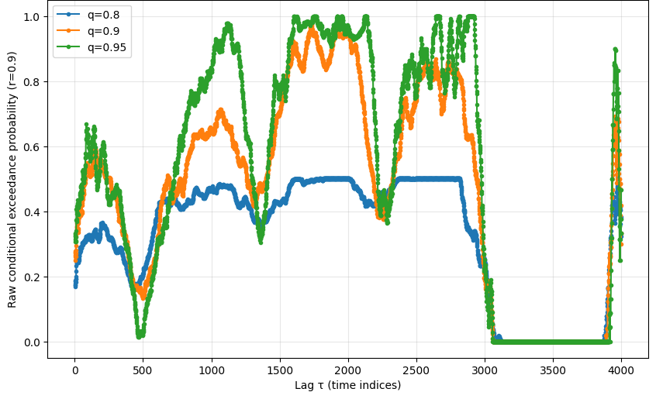
Figure 6. Raw conditional exceedance probability at target threshold r = 0.90, against lag τ, for the same three conditioning thresholds as Figure 5. The plateau structure is again visible, and the probability ceiling near 1.0 in several mid-range τ bands illustrates the same finite-sample saturation effect documented at greater length in the companion Atlas (Ramanathan, 2026b, Section 3.3): a small number of training-period episodes can drive a conditional frequency to its ceiling without implying a stable structural relationship.
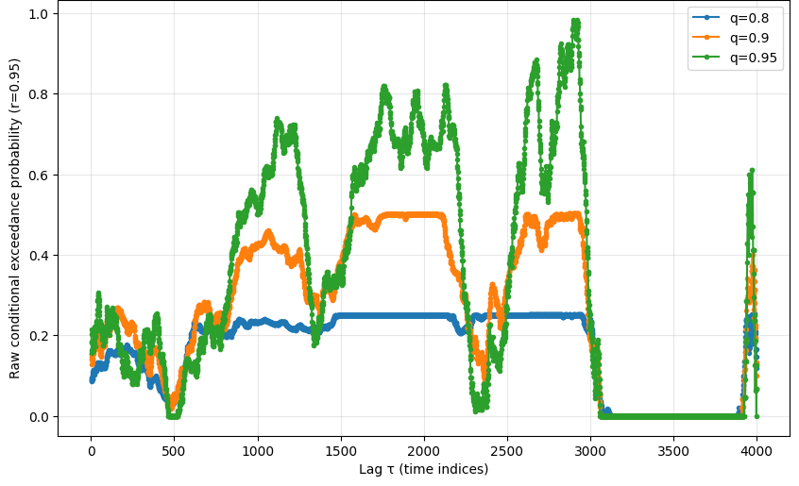
Figure 7. Raw conditional exceedance probability at target threshold r = 0.95, against lag τ. The pattern mirrors Figures 5 and 6 at a more extreme target threshold, with sparser, more saturated conditional structure consistent with a smaller pool of training-period conditioning episodes at this quantile.

10. Limitations
This study is a research prototype, and several real-world considerations are deliberately omitted from the reported figures rather than addressed through an auxiliary adjustment:
- Trade entries, but not exits, are restricted to calendar year 2025 (Section 8.1); 57–63 percent of trades in the active configurations of Table 1 realise their return using 2026 price data. The entry rule itself remains genuinely out-of-sample with respect to the pre-2025 training period, but the reported total return and Sharpe ratio are not fully determined by 2025 price action alone, and would shift if recomputed once a different span of 2026 data became available
- Transaction costs and market impact are not modelled. At the trade counts reported in Table 1 (108–147 trades per active configuration over the year), reasonable per-trade cost assumptions would erode the reported Sharpe ratios more materially than a lower-frequency strategy would experience; an explicit cost-sensitivity analysis applied to Equation 11 is left to future work
- Capital allocation constraints are not reflected in the headline Equation 11 figure; Section 8.3 and Table 1a quantify this directly — the capital-weighted return on the peak capital actually required to hold every concurrent position is 6–16 percent, a factor of 108–147× smaller than the Equation 11 figures reported in Table 1, and is the more decision-relevant number for any reader assessing realisable performance
- Dynamic position sizing is absent; every trade enters at a fixed notional regardless of the strength of the conditional probability estimate p̂ or the prevailing uncertainty bound u (Eq. 6)
- Portfolio-level interactions across configurations, and across this strategy and any other holdings, are not addressed; the configurations in Table 1 are reported independently and have not been combined or risk-budgeted against one another
- All thresholds in Equations 2–3 are estimated under an implicit stationarity assumption over the training period; the change-point structure visible in Figure 2 suggests this assumption is an approximation rather than an exact description of the sample, a concern treated at greater length for the broader cross-asset universe in the companion Atlas (Ramanathan, 2026b, Section 2.1)
- The Sharpe ratio of Equation 13 is computed on a clustered, overlapping sample of trade returns rather than an independent one (Section 9.2); it is reported as defined, but should not be read as carrying the same statistical guarantees as a Sharpe ratio computed from non-overlapping, independent return observations
- Equation 13's Sharpe ratio is, separately, not a portfolio-level statistic in the standard quantitative-finance sense (Section 8.4); the portfolio-level Sharpe computed from the strategy's actual daily mark-to-market equity curve and the peak capital of Table 1a is 0.62–1.15 (Table 1b), close to or below SPY's own buy-and-hold Sharpe over the same window, and is the figure that should anchor any judgement of whether this strategy is attractive on a risk-adjusted basis
The reported results should therefore be interpreted as evidence of exploitable statistical structure in long-horizon conditional exceedance behaviour, with entries restricted to the 2025 evaluation window but realisation extending into 2026 for a majority of trades (Section 8.1), computed exactly as Equations 1–13 specify, rather than as a claim of deployable production performance net of frictions, capital constraints, portfolio interactions, and the independent-sample assumptions that a classical Sharpe ratio interpretation would otherwise require.

11. Multiplicity and the Status of Table 1
Table 1 reports six configurations; no search over thresholds, horizons, or filter bounds was performed using 2025 outcomes, and no configuration was added to or removed from the reported set after the evaluation window closed. A further verification pass, conducted after independent reconstruction of the pipeline from the released raw data (Section 12.1), established that these six configurations are not a curated subset selected from a larger pre-registered grid in the sense the target quantile r was concerned: an exact floating-point membership test in the evaluation script silently restricted every run to r = 0.80 only, although the underlying probability table (Eq. 4–5) was built across r ∈ {0.80, 0.85, 0.90, 0.95}. The grid actually swept was therefore q ∈ {0.8, 0.9} × r = {0.8} × τ ∈ {100, 200, 300}, six cells in total, which happens to equal the six rows reported — every configuration the (unintentionally narrowed) grid could produce is shown, with none held back. This is a materially smaller multiplicity concern than the one addressed in the companion Atlas, where a configuration space of order ten to the eighth is screened and roughly 169,000 survivors are retained under permissive filters (Ramanathan, 2026b, Section 6.3); there, no individual configuration is treated as a discovery and the aggregate, asset-class-level structure is the unit of interpretation. Here, by contrast, the small grid size and the strict train/test split mean that the individual reported Sharpe ratios can be read at face value as out-of-sample performance figures for genuinely pre-specified rules per Equations 8–13, subject to the ordinary caveat that six configurations are not a large enough study to rule out favourable variance in a single evaluation year, and to the further caveat, now established directly rather than assumed, that the target threshold r was never varied in practice and the reported results should not be read as having explored sensitivity to r.

11.1 Note on Figures 1–7 and the Probability Estimator
A discrepancy was identified between the probability estimator used to produce Table 1 (Eq. 4–5, implemented in the pipeline referenced in Section 12) and the estimator used to generate Figures 1–7. The figures were produced by a separate exploratory script that computes q_thresh from the trailing sub-array of τ-day increments alone and r_thresh from the leading sub-array alone, rather than from the full increment series as Eq. 2–3 specify. Because the trailing and leading sub-arrays are overlapping but distinct subsets of the full series, their quantiles are not generally identical to the full-series quantiles used in Table 1, and a direct comparison across the six active configurations found differences in the resulting conditional probability of roughly 0.2–4 percentage points — never large enough to change which configurations clear the p_min = 0.5 eligibility bar in Equation 7, but a genuine numerical inconsistency between the equation as stated and the routine that produced the figures illustrating it. Figures 1–7 should therefore be read as a qualitatively faithful but not bit-exact illustration of the conditional exceedance structure formalised in Equations 1–5; Table 1 and all quantitative claims in Sections 8–11 are computed exclusively via the Eq. 1–5 estimator and are unaffected by this discrepancy.

12. Reproducibility
All probability estimation and trading logic are implemented in Python, following Equations 1–13 exactly. A complete code repository, including data preprocessing, probability table construction, the reliability filters of Equation 7, and the backtesting scripts used to generate Table 1 and Figures 1–7, is publicly available on GitHub at github.com/quantarram/quant-regime-research. An interactive dashboard tracking the live signal derived from this single-asset framework is maintained at quantarram.github.io/quant-regime-research/notebooks/, updated on the same daily cadence used throughout the training period. The two multi-predictor applied dashboards discussed in Section 8.15 — the Portfolio Tilt dashboard and the Gold Buy Signal dashboard — are built on the companion Atlas (Ramanathan, 2026b) rather than on this paper's single-asset pipeline and are archived separately at zenodo.org/records/20606184.

12.1 Independent verification against raw data
Following an earlier round of code review that identified and corrected the two implementation issues described below, a further, independent verification pass was conducted directly against the raw price file and the trained probability table, using a freshly written reimplementation rather than re-executing the existing pipeline. This independent reimplementation reproduced every value in the released probability table (p̂, se, N_q, N_qr) to six decimal places for all three active configurations in Table 1, and reproduced the trade count, total return, and Sharpe ratio of every active configuration exactly. This provides verification of the headline results against source data, in addition to the internal pipeline-versus-ledger reconciliation described below.
Three implementation issues were identified across this and the preceding review and are corrected in the released repository:
- the entry-signal threshold q_thresh of Equation 2 was, in an earlier version, computed using the full price series rather than Tₜᵣₐᵢₙ only, partially undermining the train/test separation for the entry rule despite the conditional probability table itself being correctly trained on pre-2025 data throughout;
- the per-trade return of Equation 10 was, in that earlier version, normalised by a single fixed reference price rather than by each trade's own entry price; and
- the construction of the target-quantile grid r_vals in the evaluation script used an exact floating-point membership test against the literal values 0.80, 0.85, 0.90, 0.95, which silently excluded three of the four r-levels present in the underlying probability table because np.arange-generated floating-point values do not test as exactly equal to those literals; every run therefore used r = 0.80 only, and Table 1's six rows constitute the entire grid that was actually swept rather than a subset selected from a larger one (Section 11).
The first two issues are corrected in the code referenced above, and the corrected pipeline includes an explicit runtime assertion confirming that no post-2024 data enters the threshold calculation. The third issue does not affect any value reported in Table 1, since every configuration that was run is shown, but it does mean the framework's sensitivity to the target threshold r was never empirically explored; this is noted as an open item for the released repository rather than retroactively patched, since correcting it would require rerunning the full grid and is left for a future revision.
The corrected pipeline additionally exports a complete, trade-level ledger (SPY_2025_trade_log.csv) recording the entry date, exit date, entry price, exit price, profit and loss, and return of every individual trade underlying Table 1, alongside a reconciliation routine that independently recomputes total return, capital-weighted return, and Sharpe ratio (Eq. 11–13, 11c) directly from this ledger and asserts exact agreement with the aggregated results for every configuration with at least one trade. This reconciliation passed without exception on the run underlying Tables 1 and 1b. Tables 2a–2c below show a representative sample of nine trades from each of the three active configurations, spanning the start, middle, and end of each trade sequence; Table 3 shows the full reconciliation, recomputed independently from the raw ledger file rather than copied from results_df, for all 372 logged trades across the three active configurations, reporting both the Equation 11 figure and the Table 1a capital-weighted figure side by side so that neither is verified or read in isolation from the other.

Table 2a. Representative sample of individual trades, q=0.8, r=0.8, τ=200 (trades 1–3, 58–60, 115–117 of 117).
Trade # | Entry date | Exit date | Entry $ | Exit $ | P&L $ | Return %
1 | 2025-01-02 | 2025-10-21 | 576.28 | 667.49 | 91.21 | 15.83
2 | 2025-01-03 | 2025-10-22 | 583.49 | 664.02 | 80.53 | 13.80
3 | 2025-01-06 | 2025-10-23 | 586.85 | 667.96 | 81.11 | 13.82
58 | 2025-03-27 | 2026-01-13 | 560.65 | 691.88 | 131.23 | 23.41
59 | 2025-03-28 | 2026-01-14 | 549.36 | 688.48 | 139.12 | 25.32
60 | 2025-03-31 | 2026-01-15 | 553.05 | 690.35 | 137.30 | 24.83
115 | 2025-07-28 | 2026-05-13 | 631.58 | 742.31 | 110.73 | 17.53
116 | 2025-07-29 | 2026-05-14 | 629.92 | 748.17 | 118.25 | 18.77
117 | 2025-07-30 | 2026-05-15 | 629.12 | 739.17 | 110.05 | 17.49
Note: invested ($) is the trade's own entry price (Eq. 10); trades 58–60 and 115–117 illustrate the entry/realisation-window distinction of Section 8.1 — entries fall within 2025 but exits fall in January and May 2026 respectively.

Table 2b. Representative sample of individual trades, q=0.9, r=0.8, τ=200 (trades 1–3, 54–56, 106–108 of 108).
Trade # | Entry date | Exit date | Entry $ | Exit $ | P&L $ | Return %
1 | 2025-01-02 | 2025-10-21 | 576.28 | 667.49 | 91.21 | 15.83
2 | 2025-01-03 | 2025-10-22 | 583.49 | 664.02 | 80.53 | 13.80
3 | 2025-01-06 | 2025-10-23 | 586.85 | 667.96 | 81.11 | 13.82
54 | 2025-03-27 | 2026-01-13 | 560.65 | 691.88 | 131.23 | 23.41
55 | 2025-05-12 | 2026-02-27 | 576.38 | 684.12 | 107.74 | 18.69
56 | 2025-05-13 | 2026-03-02 | 580.19 | 684.51 | 104.32 | 17.98
106 | 2025-07-28 | 2026-05-13 | 631.58 | 742.31 | 110.73 | 17.53
107 | 2025-07-29 | 2026-05-14 | 629.92 | 748.17 | 118.25 | 18.77
108 | 2025-07-30 | 2026-05-15 | 629.12 | 739.17 | 110.05 | 17.49
Note: q=0.9 is a stricter conditioning threshold than q=0.8 (Table 2a), so this configuration fires on a subset of similar but not identical dates; the higher bar is reflected in Table 1's higher per-trade Sharpe (4.68 vs 4.19) despite fewer trades (108 vs 117).

Table 2c. Representative sample of individual trades, q=0.9, r=0.8, τ=100 (trades 1–3, 73–75, 145–147 of 147).
Trade # | Entry date | Exit date | Entry $ | Exit $ | P&L $ | Return %
1 | 2025-01-02 | 2025-05-29 | 576.28 | 583.36 | 7.08 | 1.23
2 | 2025-01-03 | 2025-05-30 | 583.49 | 582.71 | -0.78 | -0.13
3 | 2025-01-06 | 2025-06-02 | 586.85 | 585.99 | -0.85 | -0.15
73 | 2025-09-05 | 2026-01-29 | 641.80 | 692.15 | 50.35 | 7.85
74 | 2025-09-08 | 2026-01-30 | 643.37 | 690.09 | 46.71 | 7.26
75 | 2025-09-09 | 2026-02-02 | 644.86 | 693.52 | 48.66 | 7.55
145 | 2025-12-17 | 2026-05-13 | 667.60 | 742.31 | 74.71 | 11.19
146 | 2025-12-18 | 2026-05-14 | 672.64 | 748.17 | 75.53 | 11.23
147 | 2025-12-19 | 2026-05-15 | 678.74 | 739.17 | 60.43 | 8.90
Note: trades 2 and 3 are realised losses (−0.13% and −0.15%), included here unedited because the framework does not select for winning trades within an eligible configuration — every signal fires mechanically regardless of subsequent outcome (Eq. 8). This is the lowest-Sharpe active configuration (1.70, Table 1), consistent with a shorter τ=100 horizon carrying noisier individual outcomes than the τ=200 configurations in Tables 2a–2b. Full ledger (372 rows, all three configurations) is published as SPY_2025_trade_log.csv alongside the code repository (Section 12).

Table 3. Reconciliation of Table 1 and Table 1a against the raw trade ledger, recomputed independently from SPY_2025_trade_log.csv.
q | r | τ | n (ledger vs. Table 1) | Eq.11 % (ledger vs. Table 1) | CapWeighted % (ledger vs. Table 1a) | Sharpe (ledger vs. Table 1)
0.8 | 0.8 | 200 | 117 = 117 | 1857.78 = 1857.78 | 15.79 = 15.79 | 4.1925 ≈ 4.19
0.9 | 0.8 | 200 | 108 = 108 | 1646.49 = 1646.49 | 15.20 = 15.20 | 4.6809 ≈ 4.68
0.9 | 0.8 | 100 | 147 = 147 | 622.54 = 622.54 | 6.03 = 6.03 | 1.7023 ≈ 1.70
Note: “ledger” values are computed by grouping all 372 rows of SPY_2025_trade_log.csv by configuration and recomputing Eq. 11–13 and Eq. 11c directly from the per-trade entries, independently of the aggregation performed in the original pipeline; the right-hand side of each comparison reproduces the corresponding cell in Table 1 or Table 1a. Every cell agrees to the precision shown. “Eq.11 %” is the per-trade-normalised sum (not a portfolio return; see Section 8.3) and “CapWeighted %” is the return on peak capital actually required (Eq. 11c); the two are reported side by side here specifically so neither figure is read in isolation from the other.

13. Conclusion
This paper's findings split cleanly into a robust, verifiable claim and a tested-and-negative one, and the two should not be collapsed into a single verdict. The robust claim is descriptive: the conditional probability of a future SPY price exceedance, given a historically comparable past exceedance, is systematically and substantially elevated above the unconditional base rate across the training-period record, with positive lift in all 54 tested (τ,q,r) combinations and a mean lift of 2.56× (Section 8.10). This finding requires no 2025–26 data to verify and is not put in doubt by anything that follows. The tested claim is predictive: that thresholding this probability surface into a mechanical, pre-registered entry rule (Eq. 7–8) would produce superior out-of-sample, risk-adjusted trading performance. On capital-constrained, portfolio-level terms (Sections 8.3–8.5) rather than the substantially larger cross-sectional figures (Eq. 11, Eq. 13) that the per-trade-normalised construction produces, that performance is modest and two-sided — a 6–16 percent capital-weighted return that underperforms SPY's own 28 percent buy-and-hold return over the identical window (Table 1c), alongside a 0.62–1.15 portfolio Sharpe ratio that two independent tests (a within-strategy randomisation and a parameter-free random-entry benchmark swept across holding periods from 1 to 300 days, Section 8.8) both find indistinguishable from chance.
Rather than asking what will the price do next, the conditional exceedance approach asks: given what has just happened, how much more likely is an analogous future move, and how confident can a fixed-horizon decision built on that estimate be? The descriptive answer to the first half of that question is genuinely informative, robustly so. The second half — whether that confidence translates into a tradeable edge for this specific mechanical rule, in this one evaluation year — does not yet have a positive answer, and reporting that honestly, including every statistic under every relevant convention and every test that could have falsified the result, is the paper's central methodological commitment.
The single-asset, single-period design used here is intentionally narrow, and that narrowness is what permits the strict train/test separation in Section 4 to carry genuine evidential weight even when the resulting trading performance is modest or negative. The companion Conditional Exceedance Atlas (Ramanathan, 2026b) extends the same conditional-probability construct descriptively across a much larger cross-asset universe without making a trading claim at all, trading the predictive ambition of this paper for a far broader map of where, historically, conditional tail co-movement has been strongest; the two studies are designed to be read together but evaluated on their own, separate terms, as set out in Section 3. A 23-year walk-forward extension of the trading rule (Section 8.12), built with the same prior-data-only training discipline applied independently in every year rather than frozen once, finds that the underperformance documented for 2025 alone is not a short-sample artefact: over 2003–2025 the rule returns approximately 2.3 percent annualised on a capital-weighted basis against SPY buy-and-hold's approximately 11.0 percent, with a lower Sharpe ratio (0.49 versus 0.66) as well. The gap is structural — an entry rule requiring a prior sustained rise is, by construction, unable to participate in the sharp post-crash recoveries that account for a substantial share of the index's long-run return — and widens rather than narrows with more trades and more years, directly addressing and ruling out the hypothesis that a longer evaluation horizon would reveal a latent edge. The principal contribution of this paper is therefore the verified descriptive structure, the auditable equation-by-equation framework for testing whether that structure is tradeable, and the discipline of reporting every relevant statistic and every horizon — including the ones, and the significance tests, that do not favour the strategy — rather than a demonstrated trading edge over any horizon examined. As discussed in Section 8.15, the single-predictor, binary-gate construction tested here is one specific, deliberately simple way of trading the CPE construct; the multi-predictor, continuously-weighted applications of the same statistic in the Atlas's Portfolio Tilt and Gold Buy Signal dashboards have not been subjected to the same out-of-sample and randomisation discipline established in this paper, and whether their structurally richer aggregation fares differently remains an open question for future work rather than a claim this paper makes on their behalf.

References
Adrian, T. and Brunnermeier, M. K. (2016). CoVaR. American Economic Review, 106(7):1705–1741.
Ang, A. and Bekaert, G. (2002). International asset allocation with regime shifts. Review of Financial Studies, 15(4):1137–1187.
Coles, S., Heffernan, J., and Tawn, J. (1999). Dependence measures for extreme value analyses. Extremes, 2(4):339–365.
McNeil, A. J., Frey, R., and Embrechts, P. (2015). Quantitative Risk Management: Concepts, Techniques and Tools. Revised edition. Princeton University Press.
Pagan, A. R. and Sossounov, K. A. (2003). A simple framework for analysing bull and bear markets. Journal of Applied Econometrics, 18(1):23–46.
Ramanathan, A. (2026b). A descriptive atlas of conditional exceedance structure across a multi-asset universe: joint tail co-movement among equities, crypto, commodities, rates, volatility and FX, 1993–2026. Preprint.
S&P Dow Jones Indices (2026). SPIVA U.S. Year-End 2025 Scorecard and U.S. Persistence Scorecard. S&P Global.
Spiegel, M. R. (1981). Theory and Problems of Advanced Calculus: SI (metric) edition. McGraw-Hill.
Wuthrich, M. V. and Merz, M. (2023). Statistical Foundations of Actuarial Learning and Its Applications. Springer Open.
Zarattini, C. and Antonacci, A. (2024). A century of profitable industry trends. arXiv preprint arXiv:2412.14361.
A note on scope
This manuscript characterises a research prototype’s historical out-of-sample performance over a single evaluation year and is not investment advice. Nothing in it constitutes a recommendation to transact in any instrument. Past performance, including the out-of-sample figures reported in Table 1, carries no guarantee of future results, and the omission of transaction costs, capital constraints, and portfolio-level effects noted in Section 10 means the reported figures should not be read as deployable net returns.

